## **Networking Fundamentals Homework: Rocking your Network!**

Phase 1.

Using fping on the Hollywood Office

* Fping 15.199.95.91 15.199.94.91 193.0.2.0 161.35.96.20 203.0.113.32

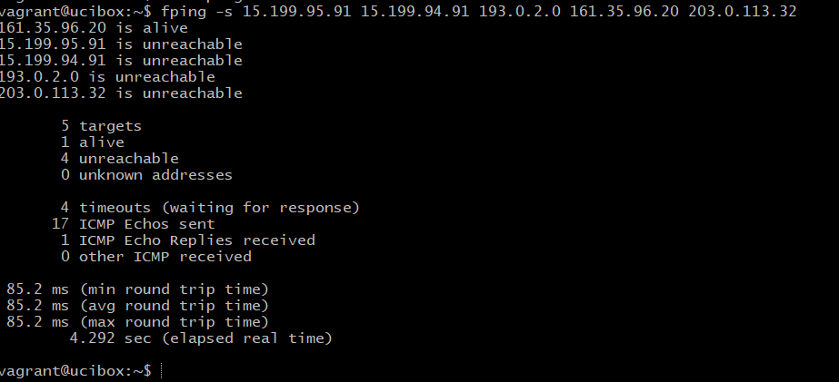

* IP address: 161.35.96.20 is responding to the ping which is vulnerability
  + Please restrict ICMP echo request for this IP address
* This is a layer 3 since we are trying to find a responsive IP address to ICMP echo request

.

Phase 2.

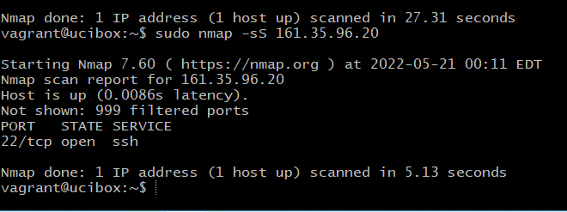

OSI layer 4 - port 22 is open and accepting connections at IP:161.35.96.20

Phase 3.

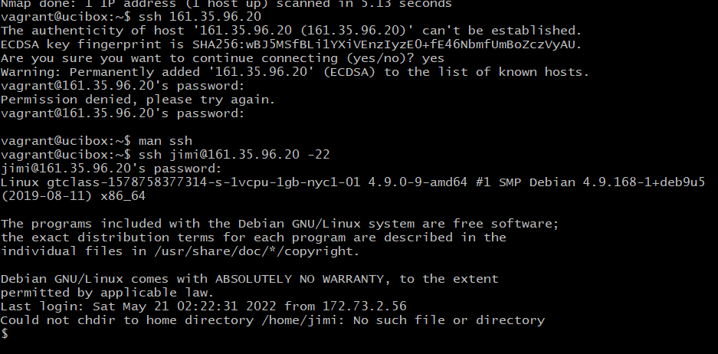

* Nano /etc/hosts
  + Rollingstone.com = 98.137.246.8
* DNS records are layer 7 on the OSI model as the DNS records acts like a phone book that links to IP addresses to domain names

Phase 4.

1. Filter with ARP protocols only and found two mac addresses for IP address: 192.168.47.200.
2. TCP captured are just acknowledgements
3. Packet #16 was unique in it had a post with an HTML form that showed the hacker’s message

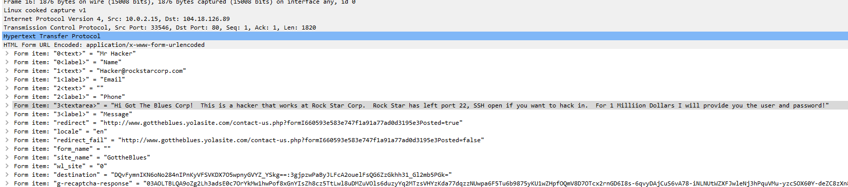

* This message is layer 7, as the message showed direct interaction from a user (ie the hacker).